问题：如何连接web 应用部署槽到azure虚拟网络

现象：将应用部署槽连接到azure虚拟网络

解决方案：通过powershell 将web应用部署槽连接到Azure虚拟网络

将web应用连接虚拟网络，首先请确保满足：

1. webapps 处于标准或高级的定价层
2. 具有点到站点连接配置网关的虚拟网络

将web应用连接虚拟网络具体操作步骤如下：

1、通过powershell 配置相应的参数并生成证书

$Configuration = @{}  
$Configuration.WebAppResourceGroup = "[Your web app resource group]"  
$Configuration.WebAppName = "[websitename/slotname]"  
$Configuration.VnetSubscriptionId = "[Your vnet subscription id]"  
$Configuration.VnetResourceGroup = "[Your vnet resource group]"  
$Configuration.VnetName = "[Your vnet name]"

$Configuration.WebAppLocation = "[Your web app Location]"、$Configuration.GeneratedCertificatePath = "[Your local path\Certificate.cer]"

$vnet = New-AzureRmResource -Name "$($Configuration.WebAppName)/$($Configuration.VnetName)" -ResourceGroupName $Configuration.WebAppResourceGroup -ResourceType "Microsoft.Web/sites/virtualNetworkConnections" -PropertyObject @{"VnetResourceId" = "/subscriptions/$($Configuration.VnetSubscriptionId)/resourceGroups/$($Configuration.VnetResourceGroup)/providers/Microsoft.ClassicNetwork/virtualNetworks/$($Configuration.VnetName)"} -Location $Configuration.WebAppLocation -ApiVersion 2015-07-01

#create certificate , run once befroe

$certBytes = [System.Convert]::FromBase64String($vnet.Properties.certBlob)

[System.IO.File]::WriteAllBytes("$($Configuration.GeneratedCertificatePath)", $certBytes)

2、将上一步骤生成的证书上传到已经创建好的VNET中

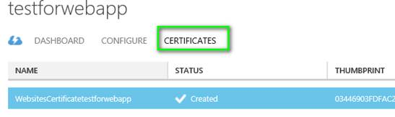

3、获取点到站点包，并将其供给web应用。将如下内容的GetNetworkPackageUri.json文件，保存到本地环境中，例如：D:\cert\GetNetworkPackageUri.json。

 {  
    "$schema": "http://schema.management.azure.com/schemas/2014-04-01-preview/deploymentTemplate.json#",  
    "contentVersion": "1.0.0.0",  
    "parameters": {  
        "certData": {  
            "type": "string"  
        },  
        "certThumbprint": {  
            "type": "string"  
        },  
        "networkName": {  
            "type": "string"  
        }  
    },  
    "variables": {  
        "legacyVnetName": "[concat('Group ', resourceGroup().name, ' ', parameters('networkName'))]"  
        },  
        "resources": [  
        ],  
    "outputs" : {  
        "PackageUri" :  
        {  
        "value" : "[listPackage(resourceId('Microsoft.ClassicNetwork/virtualNetworks/gateways/clientRootCertificates', parameters('networkName'), 'primary', parameters('certThumbprint')), '2014-06-01').packageUri]", "type" : "string"  
        }  
    }  
}

执行下面部署的脚本：

$parameters = @{"certData" = $vnet.Properties.certBlob ;certThumbprint = $vnet.Properties.certThumbprint ;"networkName" = $Configuration.VnetName }

$output = New-AzureRmResourceGroupDeployment -Name unused -ResourceGroupName $Configuration.VnetResourceGroup -TemplateParameterObject $parameters -TemplateFile  D:\cert\GetNetworkPackageUri.json

 将点到站点包上载到应用

$vnet = New-AzureRmResource -Name "$($Configuration.WebAppName)/$($Configuration.VnetName)/primary" -ResourceGroupName $Configuration.WebAppResourceGroup -ResourceType "Microsoft.Web/sites /virtualNetworkConnections/gateways" -ApiVersion 2015-07-01 -PropertyObject @{"VnetName" = $Configuration.VnetName ; "VpnPackageUri" = $($output.Outputs.packageUri).Value } -Location $Configuration.WebAppLocation

4、执行成功后，等待几分钟，就可以通过Portal看到VNET中已经连接了一个客户端：

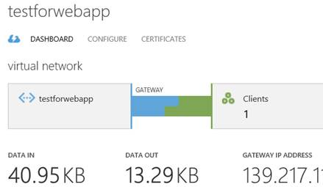

 关于部署槽连接到虚拟网络，只需要修改webAppname 和ResourceType，修改如下：

$Configuration.WebAppName = "[websitename/slotname]"

$vnet = New-AzureRmResource -Name "$($Configuration.WebAppName)/$($Configuration.VnetName)" -ResourceGroupName $Configuration.WebAppResourceGroup -ResourceType "Microsoft.Web/sites/slots/virtualNetworkConnections" -PropertyObject @{"VnetResourceId" = "/subscriptions/$($Configuration.VnetSubscriptionId)/resourceGroups/$($Configuration.VnetResourceGroup)/providers/Microsoft.ClassicNetwork/virtualNetworks/$($Configuration.VnetName)"} -Location $Configuration.WebAppLocation -ApiVersion 2015-07-01